

SIMATS ENGINEERING

Saveetha Institute of Medical and Technical Sciences
Chennai- 602105

Student Name: ROSHAN.K Reg. No.: 192425014
Course Code: CSA0624 Slot: D
Course Name: Design and analysis of algorithm
Course Faculty: Dr. Gnanajeyaraman Rajaram
Project Title: AI-based crop yield production and optimization
Module Photographs:
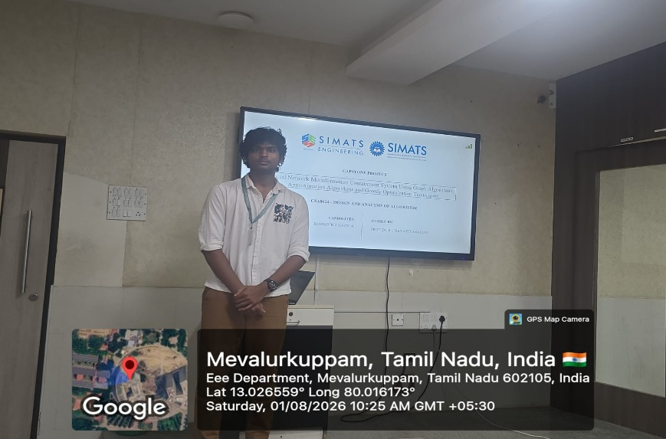
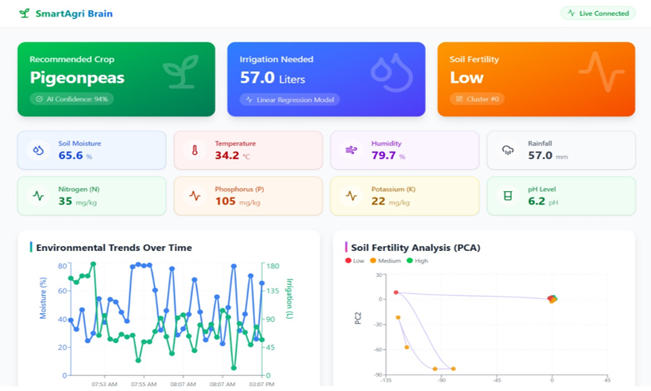
Project Description:
- The proposed system successfully integrates IoT and machine learning techniques.
- Real-time environmental data is effectively processed for decision-making.
- The system provides irrigation prediction, crop recommendation, and field zoning.
- Automated decision support improves farming efficiency.

Student Signature Guide Signature

